3:00 PM 11-17-23 BC

Topics to Mention

What were some specific issues with the way the DHF was organized?

-criteria was DHF was that it needed to be easily navigable and adam had a hard time finding things because some things weren’t really where they were expected to be based on what templates and numbering wasn’t there (OVERALL ORGANIZATION)

-research folder had nothing in it

-reference materials pointed to patents used in benchmarking, add sources to the amazon sources (oops)

-we have a file that has a bunch of links that we have done now

-potentially post link to references on the discord

-logged to the time to the meetings (and also link to the meeting notes)

What sort of specifics needed to be included in the Gantt Chart?

-sign in and witness pages on the gantt chart (update it regularly and sign it and date it), best way to do this

-gantt chart (task -> startdate enddate assignee (person assigned to task revisee (person who did revision) revision dates)

-potentially use something that can be a premade format for the gantt chart , could look like this:

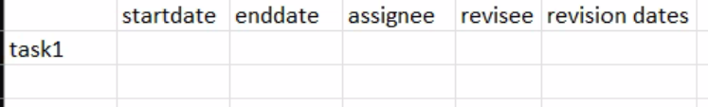

We assumed that our current progress with the DHF and Progress Report was okay to be submitted, however, our scores aren’t what we were expecting. Is there anything straight up that you need to tell us? How can we improve for the better? We would like to have more specific criticisms.

-figures need captions and figure numbers

**-focus on formatting**

-font in table should not exceed font in test

-avoid images on tables if not needed

-don't make tables too huge

-less solution focused

-do takeaways for each product and stuff and do deeper analysis (how and why and go over them more in depth)

*-****Progress Report 2 IS solution-based***

I feel like a lot of the criticisms and critiques on the score sheets are more like questions. Could we go over some specifics on what needed to be corrected?

-DHF organization

We understand most criticisms but we feel like many still have been prevented.

How to improve for later:

-concept feasibility screening (regular assignment)

-not difficult highly flexible and highly applicable project

In Meeting Notes

-both objective and comparative criticism by graded

-work on some drawing later

User Needs Survey

3:45PM 11-17-23 BC